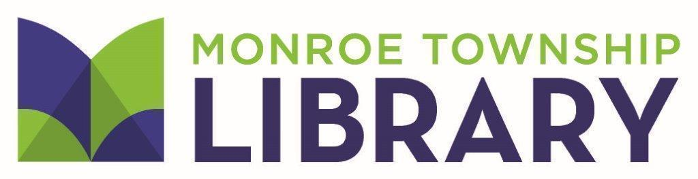
4 Municipal Plaza • Monroe Township, NJ 08831 • (732) 521-5000 • www.monroetwplibrary.org
Director’s Report
Library Board of Trustees Meeting
September 16, 2025
EMERGENCY ACTION PLAN/UNEXPECTED CLOSING POLICY
In your packet is another copy of the revisions to the policy/plan. I have scheduled a security walkthrough with the representative from the GSMJIF (Garden State Municipal Joint Insurance Fund) for October 8. Donna Rogers who is the Library’s representative on the Township Safety Committee will go through the library with him. The representative from the GSMJIF is also able and willing to provide active shooting training for Library staff. He is booking into 2026 so I hope to get that on the calendar soon. I will ask during the meeting that you pass the policy as reviewed at the July meeting, with the understanding that the active shooter portion may be revised once we meet with the representative and have the training.
CIRCULATION POLICY REVISIONS
A number of new items are about to be added to the collection. Because of the varying borrowing periods and item types across library collections, Jackie Gryszka (Circulation Manager) and Kristine Campanale (Cataloger) worked together to streamline and consolidate item types so that it is easier for both borrowers and staff to understand. The policy will be available in your binders on the night of the meeting as it will not be ready before the mailing. The changes will be only to that portion of the policy.
SOLAR CARPORT PROJECT
The Township is moving ahead with its solar project. The Library will have solar carports installed. A presentation was made at the July Council meeting. I met with Kevin McGowan, Business Administrator, representatives from DPW and Schneider Electric to talk about impact to Library operations during the construction/installation period. There is not a firm project start date. I will continue to provide updates as I receive the information.
ASSISTANT DIRECTOR SEARCH UPDATE
As I mentioned in my email, I have decided to pause the Assistant Director search for the time being. After serving in my new role, it became clear that the job posting as written is not what is needed. I am taking this opportunity to rethink the structure of the administration to best position the Library for the future.
ASSOCIATION OF BOOKMOBILE AND OUTREACH SERVICES CONFERENCE
Kelly Palombit (Outreach Manager) and I will be attending the Association of Bookmobile and Outreach Services (ABOS) conference in St. Louis, MO, from October 7-10.
UPCOMING VIRTUAL AUTHOR TALKS
Please visit www.monroetwplibrary.org/authortalks for all upcoming and archived author talks.

Respectfully submitted,
Karen Klapperstuck

